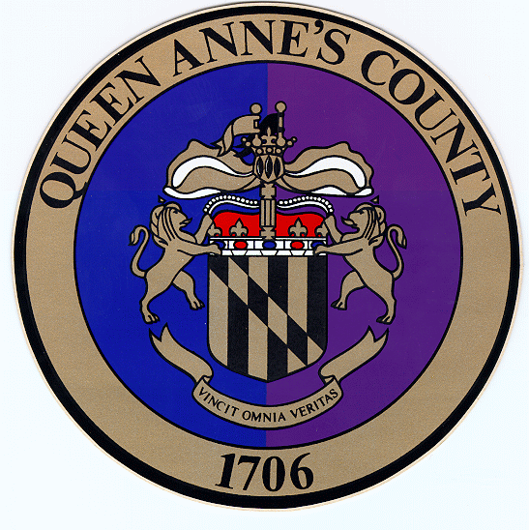 Queen

Anne’s

County
County Commissioners:
James J. Moran, At Large
Jack N. Wilson, Jr., District 1
Stephen Wilson, District 2
Philip L. Dumenil, District 3
Christopher M. Corchiarino, District 4

THE COUNTY COMMISSIONERS OF
QUEEN ANNE’S COUNTY
The Liberty Building
107 North Liberty Street

Centreville, MD 21617

Telephone: (410) 758-4098
Fax: (410) 758-1170
e-mail: QACCommissioners&Administrator@qac.org

County Administrator: Todd Mohn
Executive Assistant to County Commissioners: Margie A. Houck
County Attorney: Patrick Thompson, Esquire

Press Release
March 25, 2020
Beth Malasky
bmalasky@qac.org

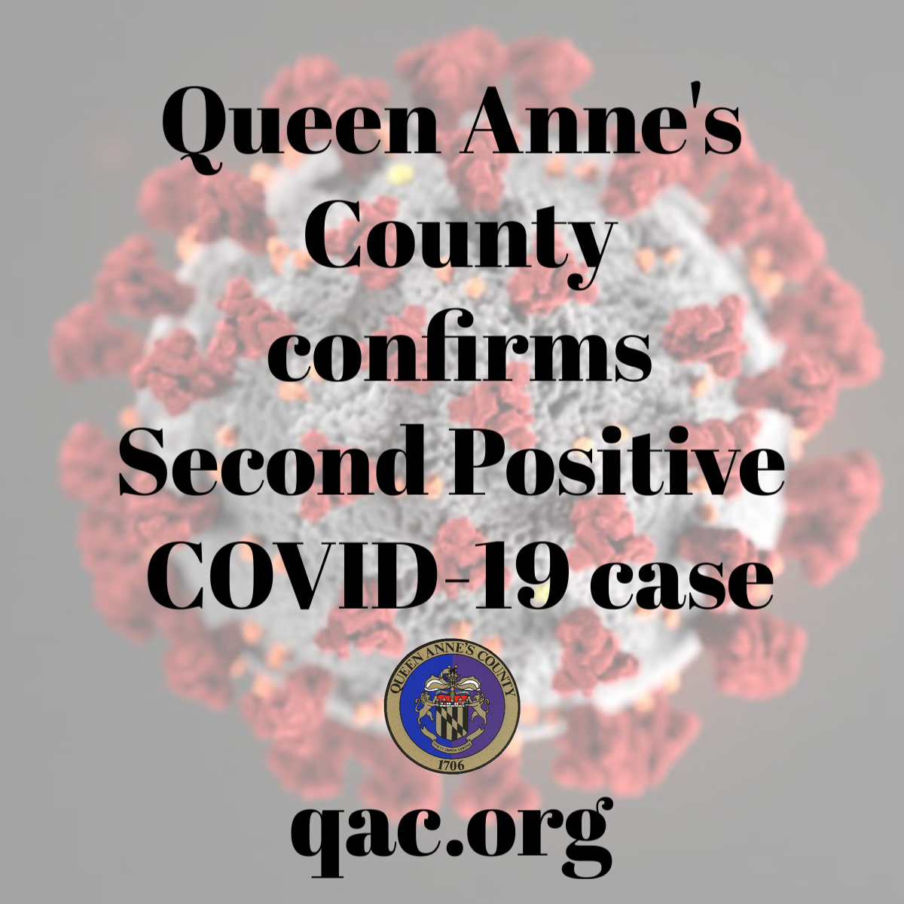

Second Positive Case of Novel Coronavirus Confirmed in Queen Anne’s County

Queen Anne’s County Health Officer, Joseph A. Ciotola, Jr., M.D., announced the second confirmed case of COVID-19 in Queen Anne’s County, Maryland, Wednesday March 25, 2020.

The individual that tested positive in Queen Anne’s County is a male in his 20’s. This case is considered a community transmission since he did not travel out of the country; however he did recently travel outside of Queen Anne’s County. He is currently in stable condition and has no underlying health issues.

In addition to this second confirmed case, there are two other related patients that are under investigation. All of these individuals have been quarantined. This case is not connected with the County’s first positive case.

COVID-19 is a highly contagious disease of the lungs. Symptoms include fever, cough and shortness of breath. COVID-19 is spread by contact with an infected person, usually through coughing and sneezing or between people who are in close contact with one another (within 6 feet). It is also possible that a person can become infected by touching a surface or an object that has the virus on it and then touching their own mouth, nose and possibly eyes. COVID-19 is a new virus in humans; most people have little or no immunity.

All County residents are instructed to continue with social distancing and if you are having symptoms to contact your primary care physician. Persons who have been exposed to the virus have the potential to infect others before they display symptoms. If you have sick family members recovering at home please use this link for more information: https://www.cdc.gov/coronavirus/2019-nCoV/index.html
Queen Anne's County Health Department has set up an information line for the public to call with questions about COVID-19. Staff will be available by phone from 8:00 AM - 4:30 PM Monday through Friday, 443-262-9900 qaccovid19.callcenter@maryland.gov
Queen Anne’s County Government has set up an information line for questions about county departments and services during COVID-19. This line is open Monday through Friday from 8:00 am till 4:30 pm. Call 443-786-9529
This is a rapidly changing event so follow us on social media @QACGOV and qac.org online for the latest updates to county government. For the latest information on COVID-19 follow Queen Anne’s County Department of Health @QADOH and qahealth.org

